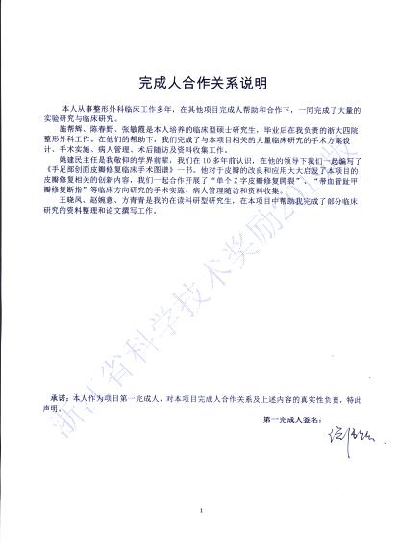

完成人合作关系情况汇总表

序号 | 合作方式 | 合作者 | 合作时间 | 合作成果 | 证明材料编号 | 备注
1 | 专著合著 | 姚建民、谈伟强等 | 2006．12 | 《手足部创面皮瓣修复临床手术图谱》
2 | 论文合著 | 姚建民、谈伟强、王晓凤、方青青、赵婉意、陈春野、张敏霞、施帮辉 | 2018.9 | Wang XF, Fang QQ, Zhao WY, Han K, Wang WY, Chen CY, Zhang MX, Shi BH, Tan WQ* (谈伟强), Yao JM*. Clinical Application of 3-Dimensional Continuous Suturing Technique for Triangular Wounds. Ann Plast Surg. 2018 Sep; 81(3):316-321.
3 | 论文合著 | 姚建民、谈伟强 | 2012.9 | Tan WQ (谈伟强), Xu JH, Yao JM. The single z-plasty for cleft palate repair: a preliminary report. Cleft Palate Craniofac J. 2012 Sep;49(5):635-9.
4 | 论文合著 | 姚建民、谈伟强 | 2010.12 | Tan WQ (谈伟强), Xu JH, Yao JM. Vascularized composite toenail flap for distal defects of finger. J Plast Reconstr Aesthet Surg. 2010 Dec;63(12):2201-3.
5 | 论文合著 | 姚建民、谈伟强 | 2007.11 | Xu JH, Xu JH, Chen H, Tan WQ* (谈伟强), Yao JM. Linguiform rotation flap for amputations of the fingertip. Scand J Plast Reconstr Surg Hand Surg. 2007.11, 41(6): 320-5.
6 | 论文合著 | 谈伟强、姚建民 |  | Xu JH, Gao ZJ, Yao JM, Tan WQ, Dawreeawo J. Foster replantation of fingertip using neighbouring digital artery in a young child. J Plast Reconstr Aesthet Surg.2010;63(6):e532-4.
